**Backend (Java Spring Boot) Setup Instructions**

**Step 1: Install Java SE 8 on your system.**

Open <https://www.oracle.com/in/java/technologies/javase/javase-jdk8-downloads.html>

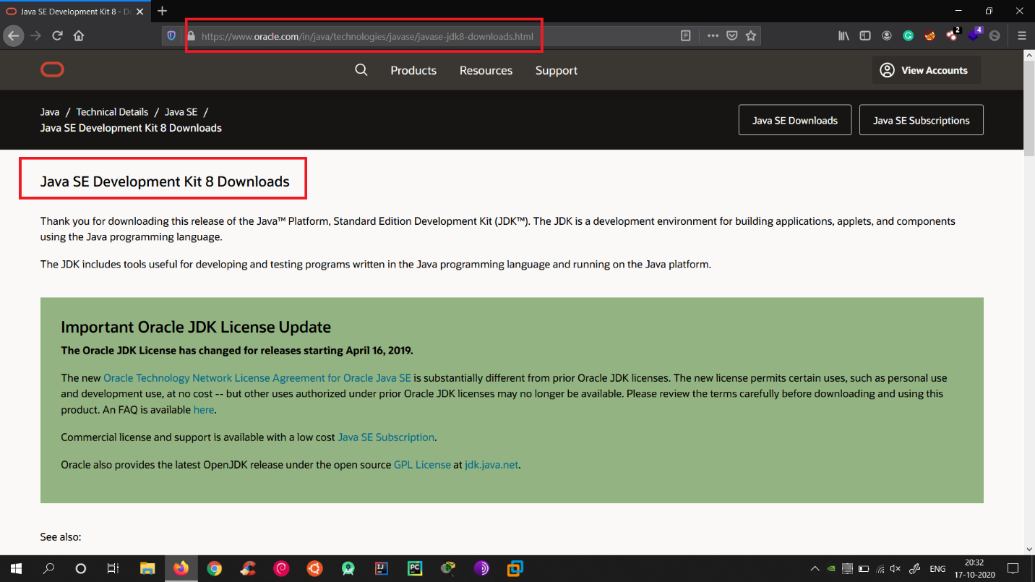

Scroll down and select **Windows version**

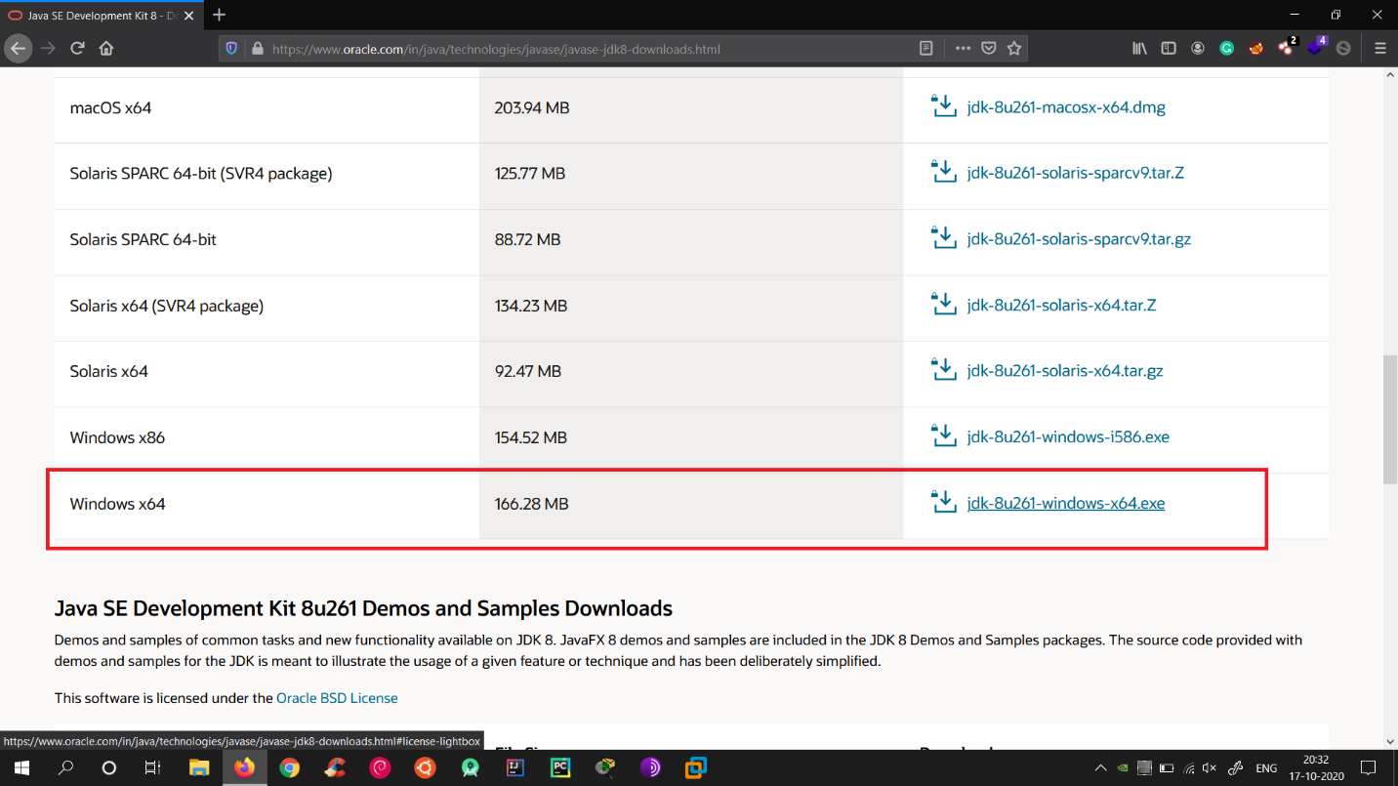

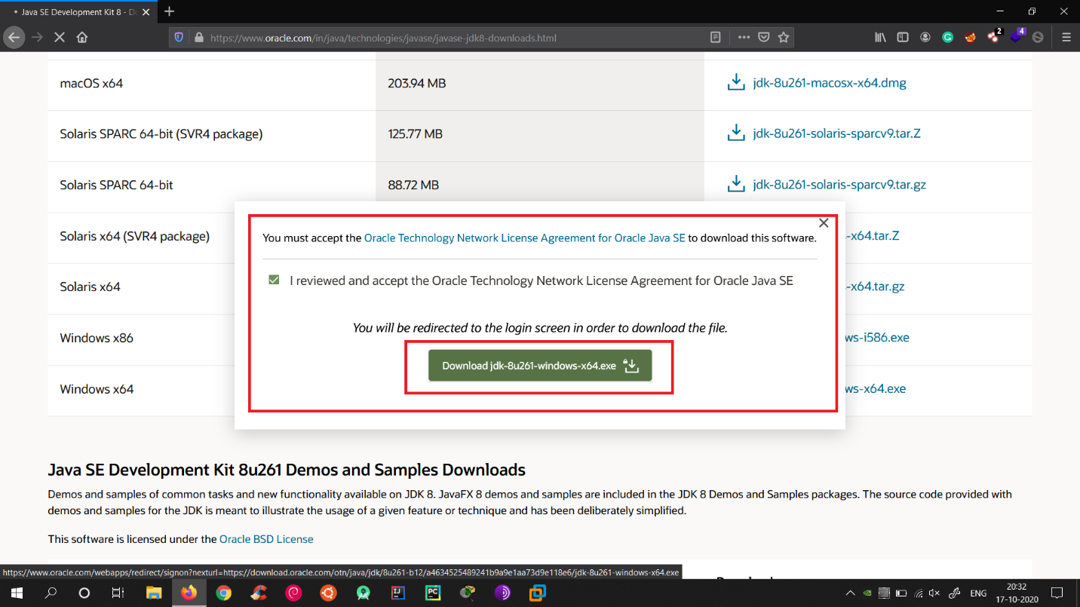

After selecting the version **Agree T&C** and **download exe file**

**Step 2: Configure Java 8 on your System**

Double click on the exe and install Java 8.

Now you have to configure your Environment variables.

Right Click on **This PC** -> **Properties**  
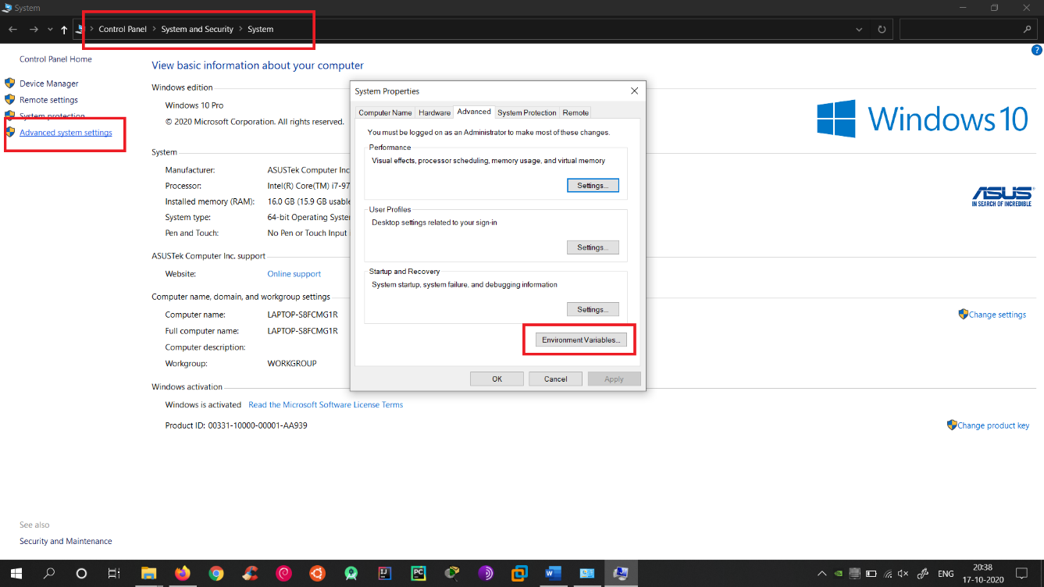

Click on **Advanced System Settings**.  
You will see a Window and Click on **Environment variables**.

Now you will see two types of variables:  
**User variables** and **System variables**.

In **System variables** search for **Path** variable.

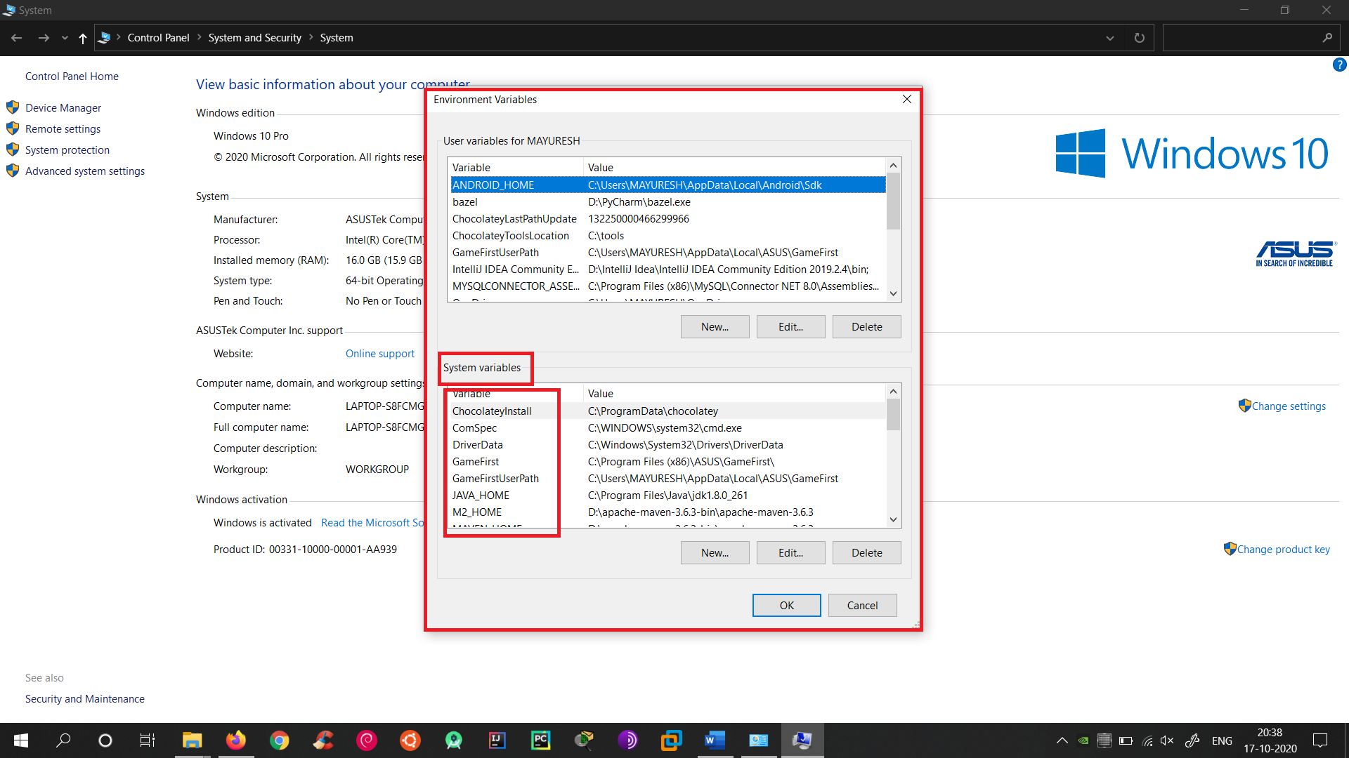

**Double click** on **Path** variable and add your Java path to it.

Click on **New** and Copy and Paste the **Java/bin** path here.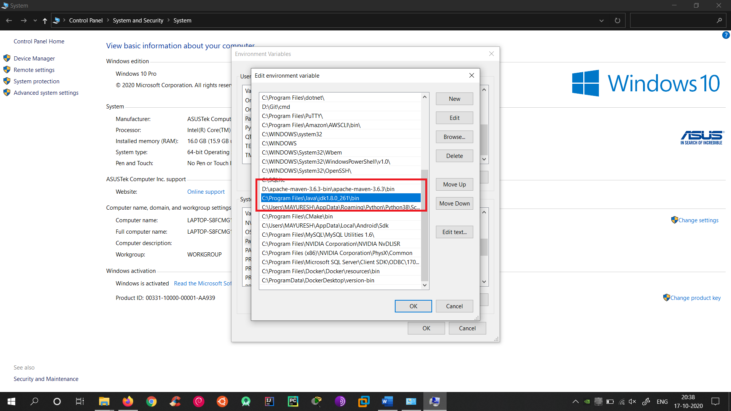

Open **CMD** and type **java -version**.

If everything is OK, then your will see following output.

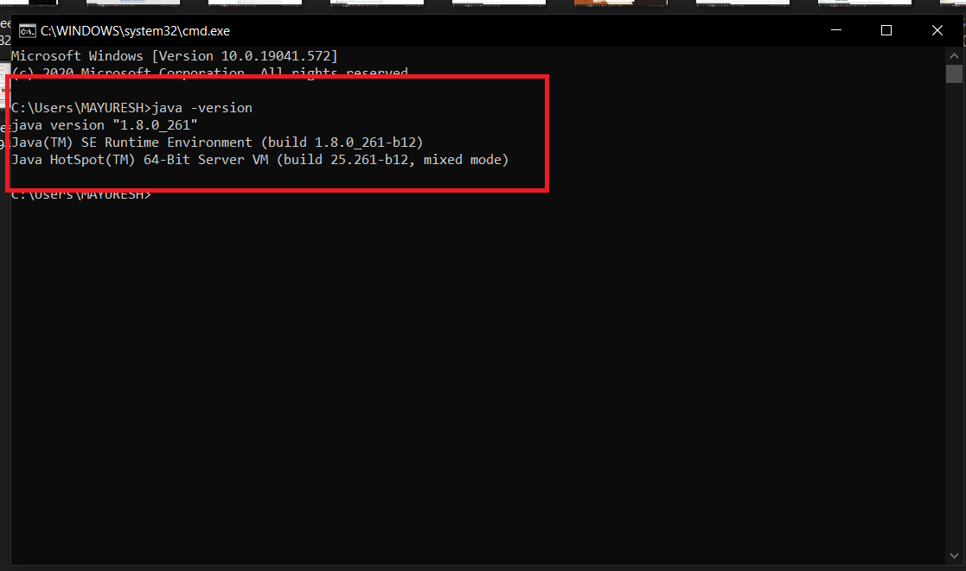

**Step 3: Install IntelliJ IDEA (IDE)**

Open

<https://www.jetbrains.com/idea/>

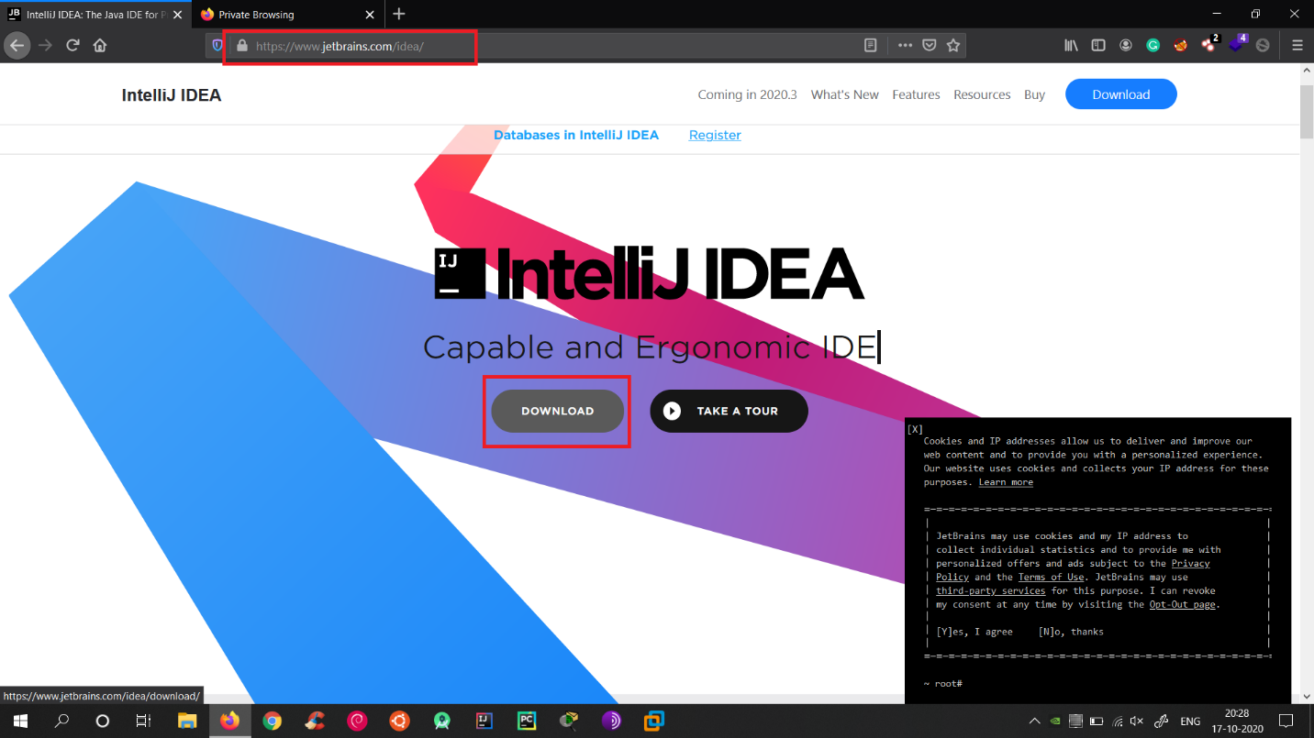

Click on **Download** and select **Community version** and Download exe and **Install it**.

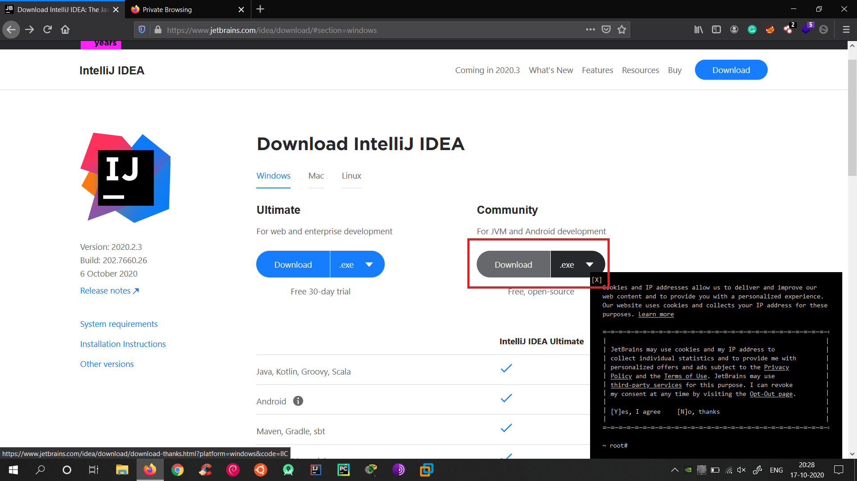

**Step 4: Install MariaDB Server**

Open

<https://mariadb.org/download/> and click Download

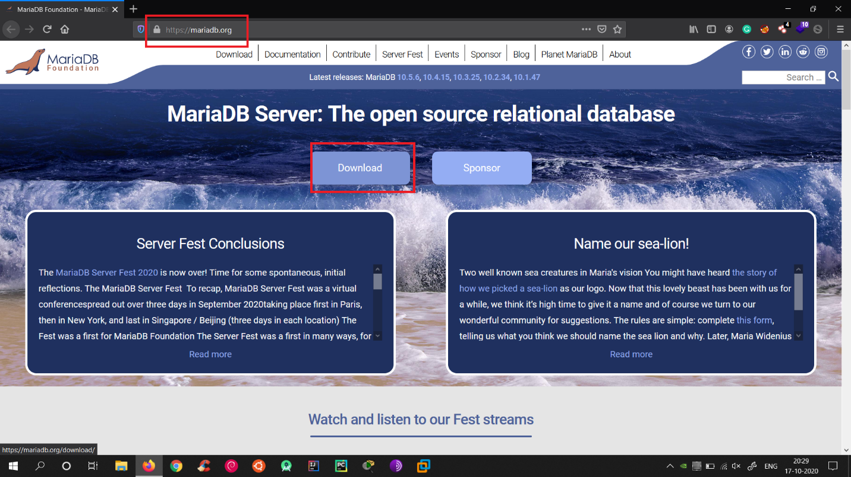

Now select the options shown in Screenshot.

Click on Download.

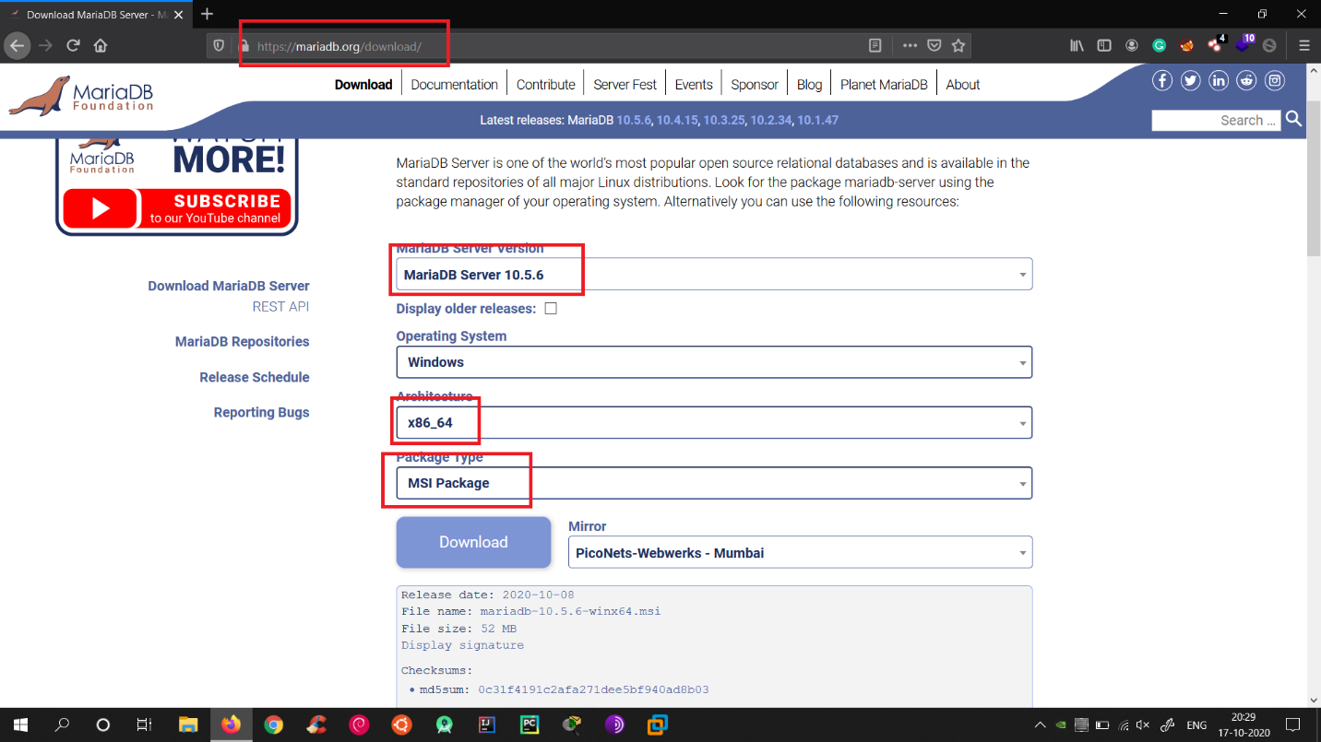

While installation you will be prompted for Username and Password.  
Give both values as **root** and **root**.

Also just confirm that it will be using **port 3306** and **Install**.

Now in **Windows Search bar** search for **HeidiSQL** and open it.

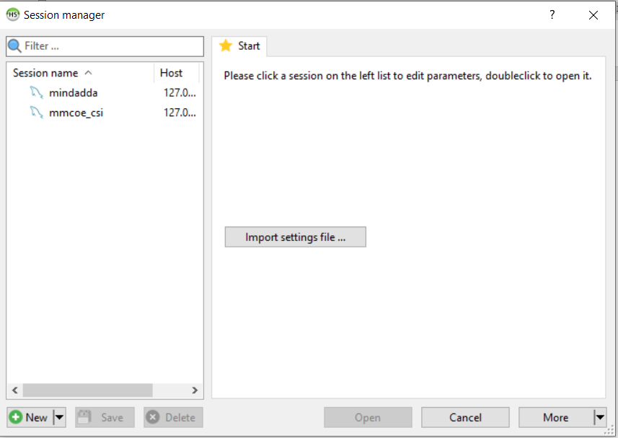

Click on New and Enter the Values as shown below.

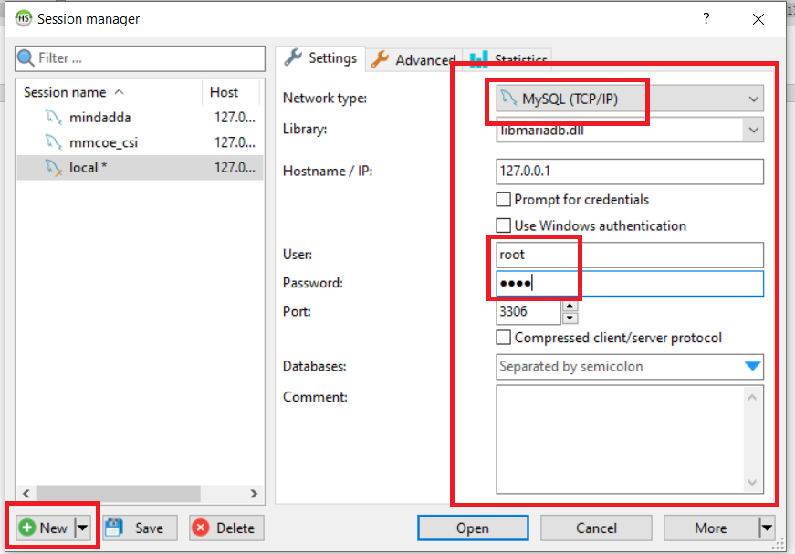

After doing that you will see this.

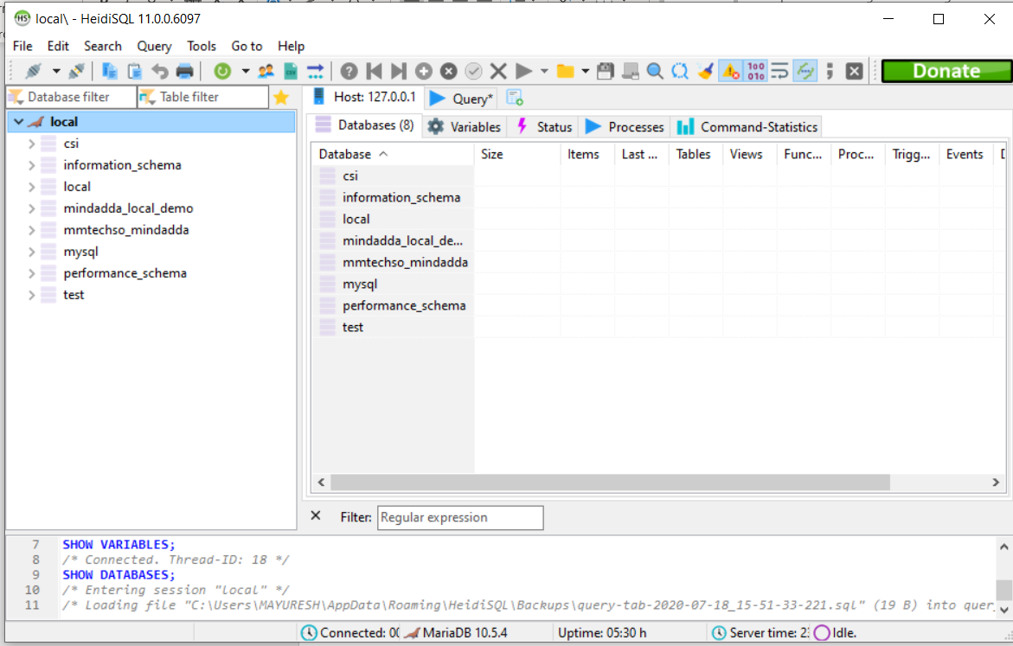

**Step 5: Install MYSQL WorkBench**

Open

<https://www.mysql.com/products/workbench/>

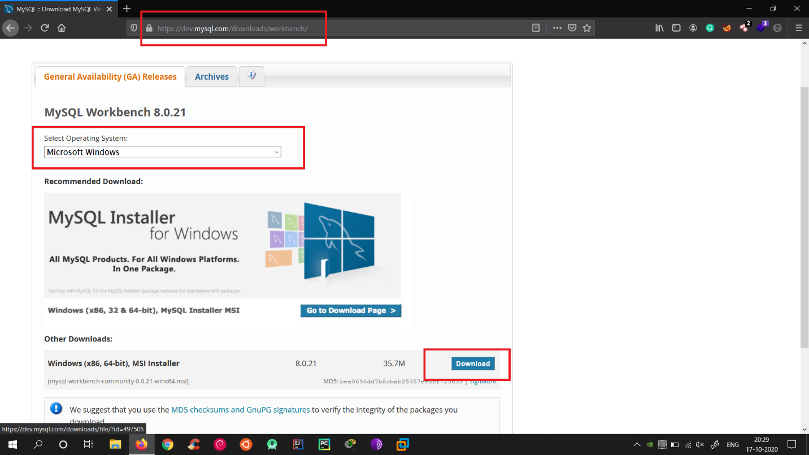

Select **Windows** and click on **Download**.

To download this, you require **Oracle account**. So, **create new** if you do not have it.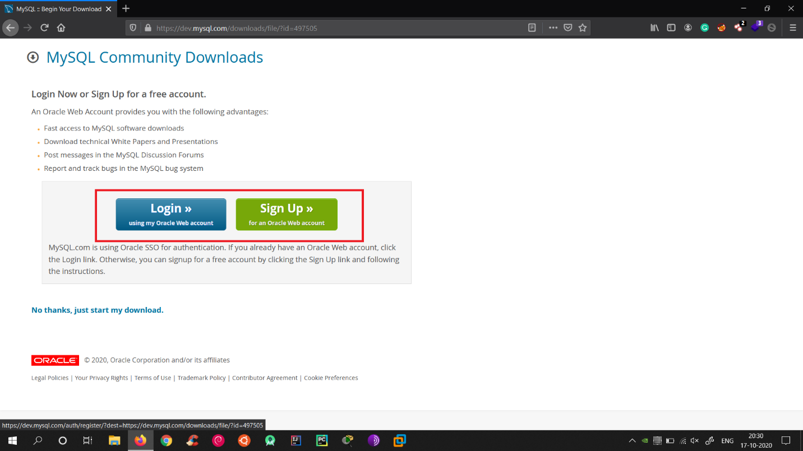

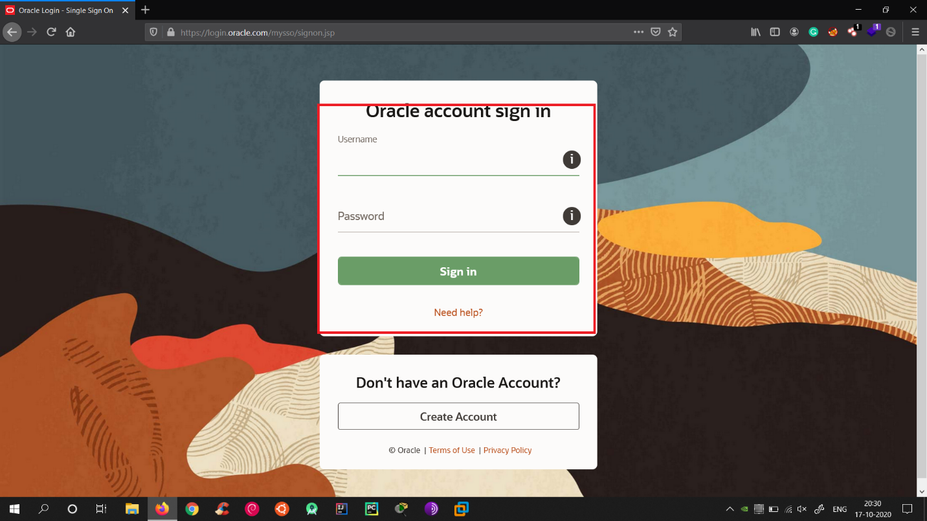

After Sign in you will see the below screen.

Click on **Download** and **Install the exe**.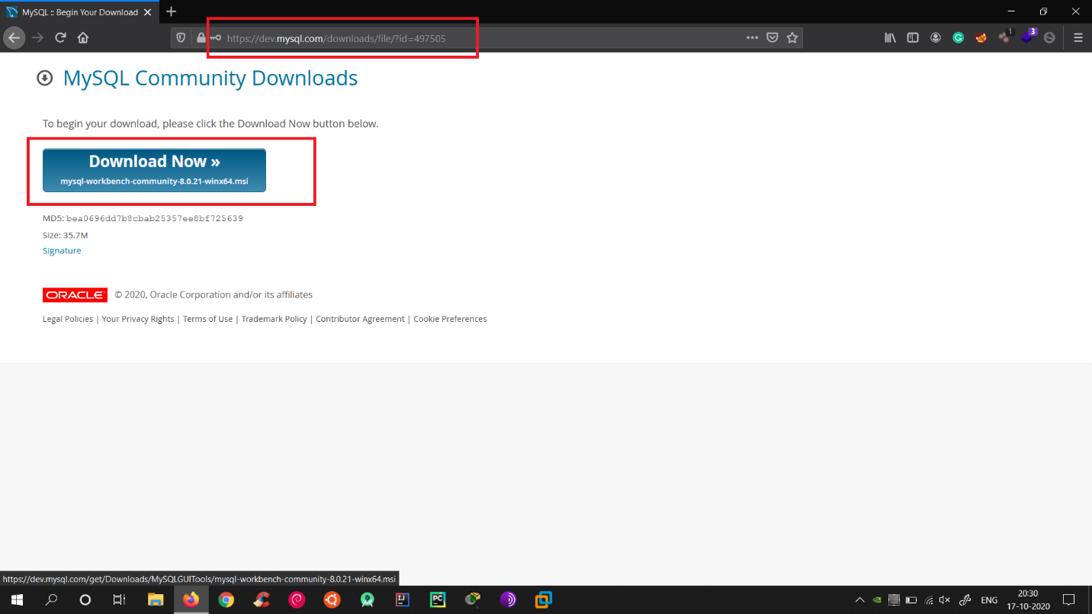

After installation open MYSQL Workbench.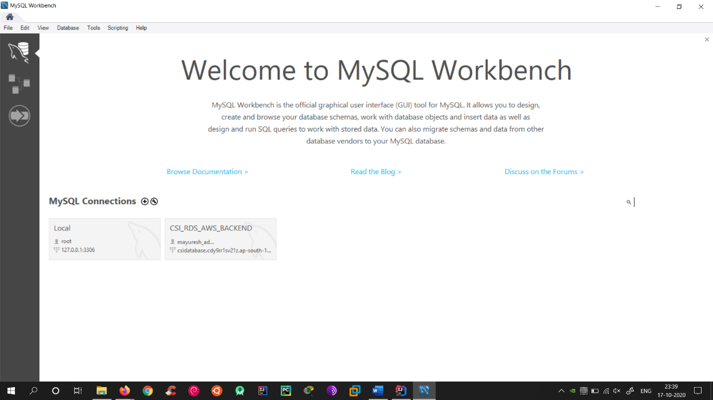

Now click on + and Enter the values.

Use Username as root and Password as root.

Leave Default Schema empty.

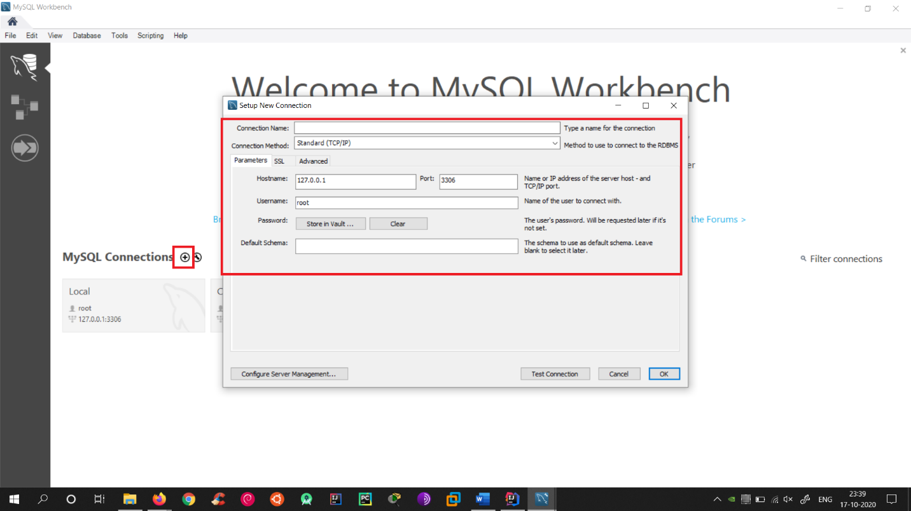

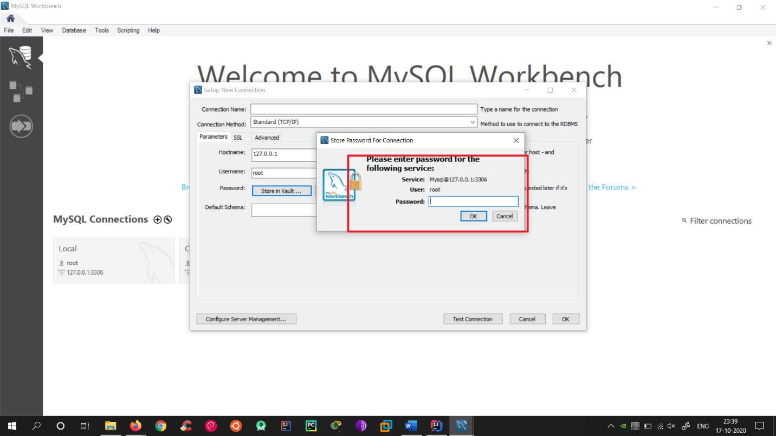

Now after filling all the values Click on Test Connection.

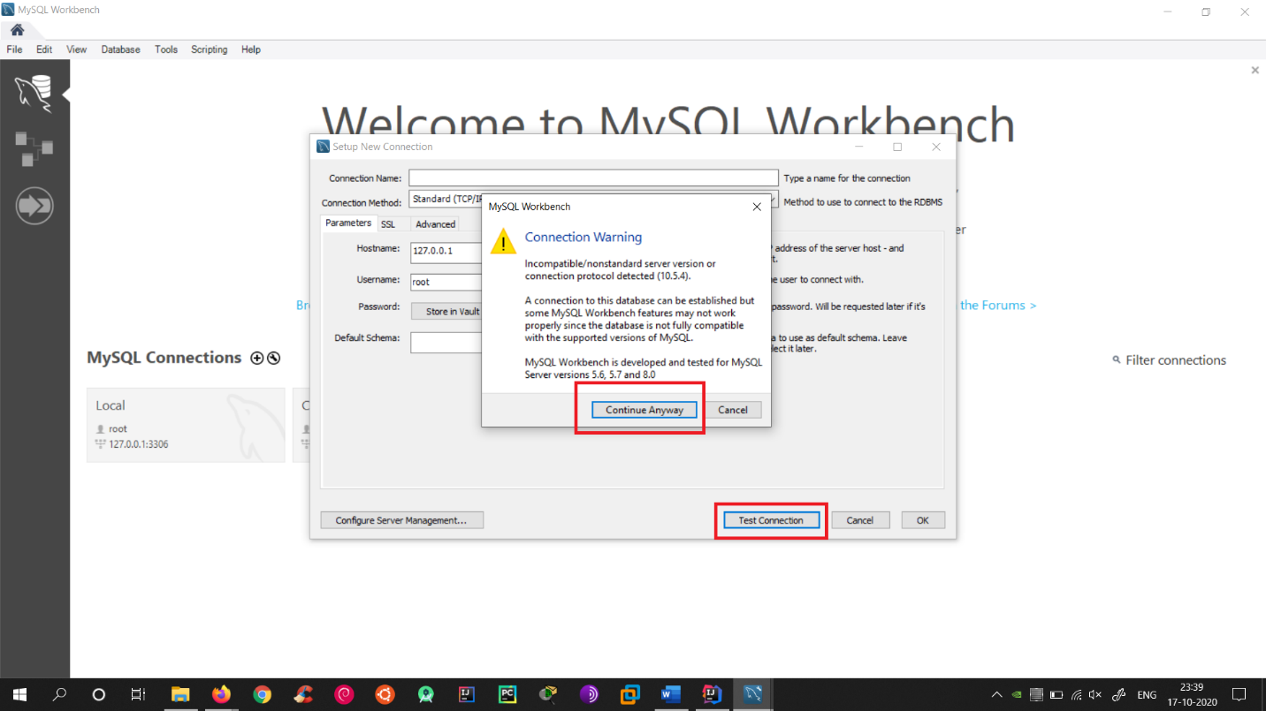

If you see the below output then everything is correct.

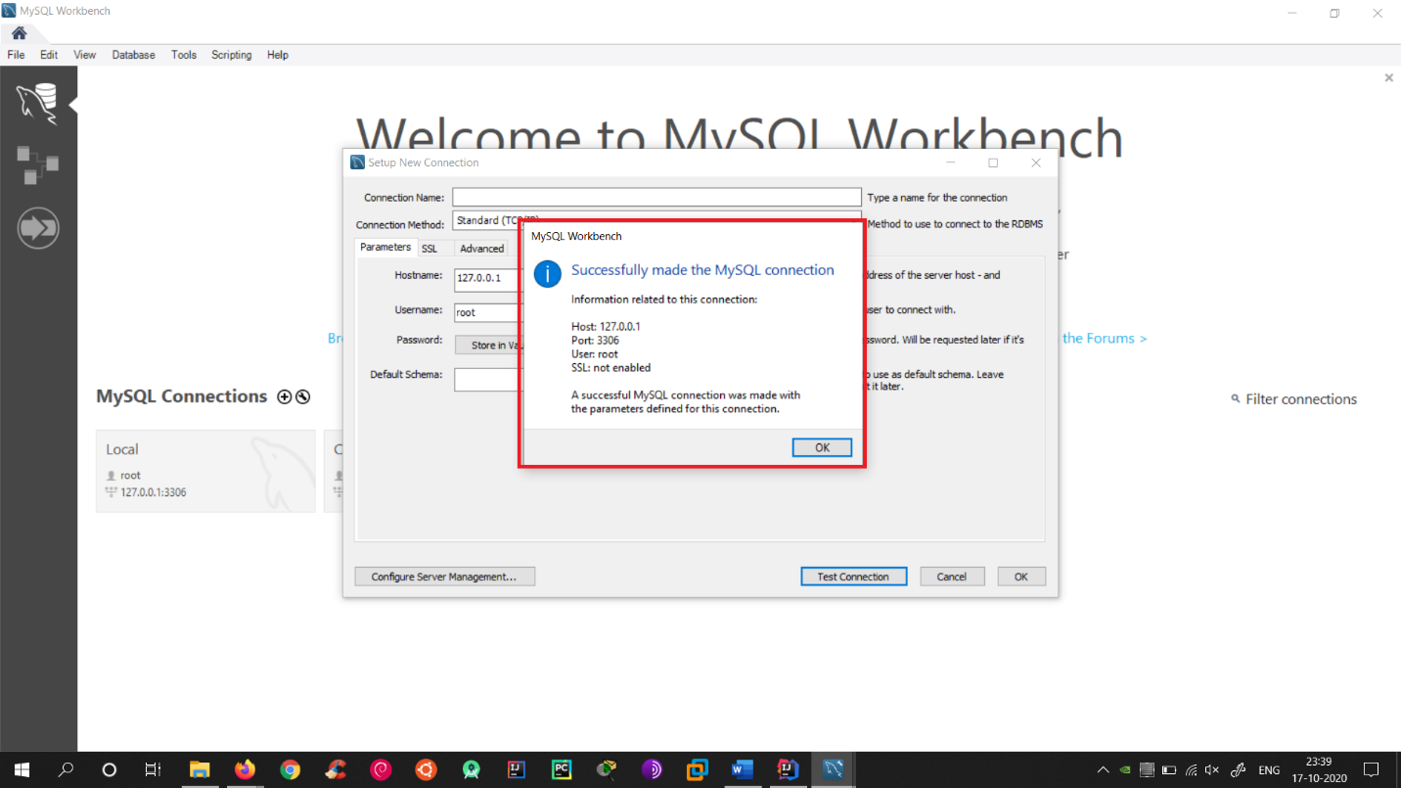

**Step 6: Download Maven**

Open

<http://maven.apache.org/download.cgi> and scroll down and select the **option shown in Screenshot**.

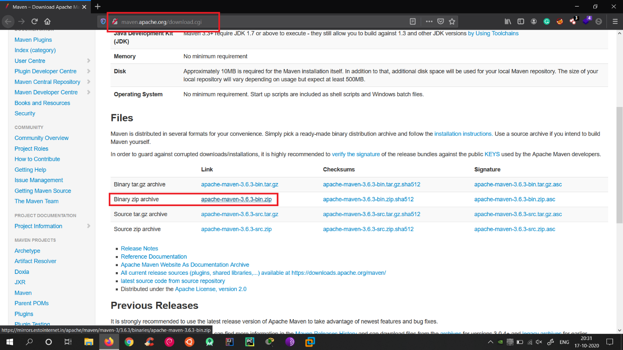

After Download just **extract the zip file** anywhere you want.

**Do not extract it in C Drive.**

Now you have to set Path in your environment variables.

Click on My PC -> Properties



Click on **Advanced System Settings**.  
You will see a Window and Click on **Environment variables**.

Now you will see two types of variables:  
**User variables** and **System variables**.

In **System variables** search for **Path** variable.



**Double click** on **Path** variable and add your **Maven** path to it.

**(You need to create two new variables as shown)**

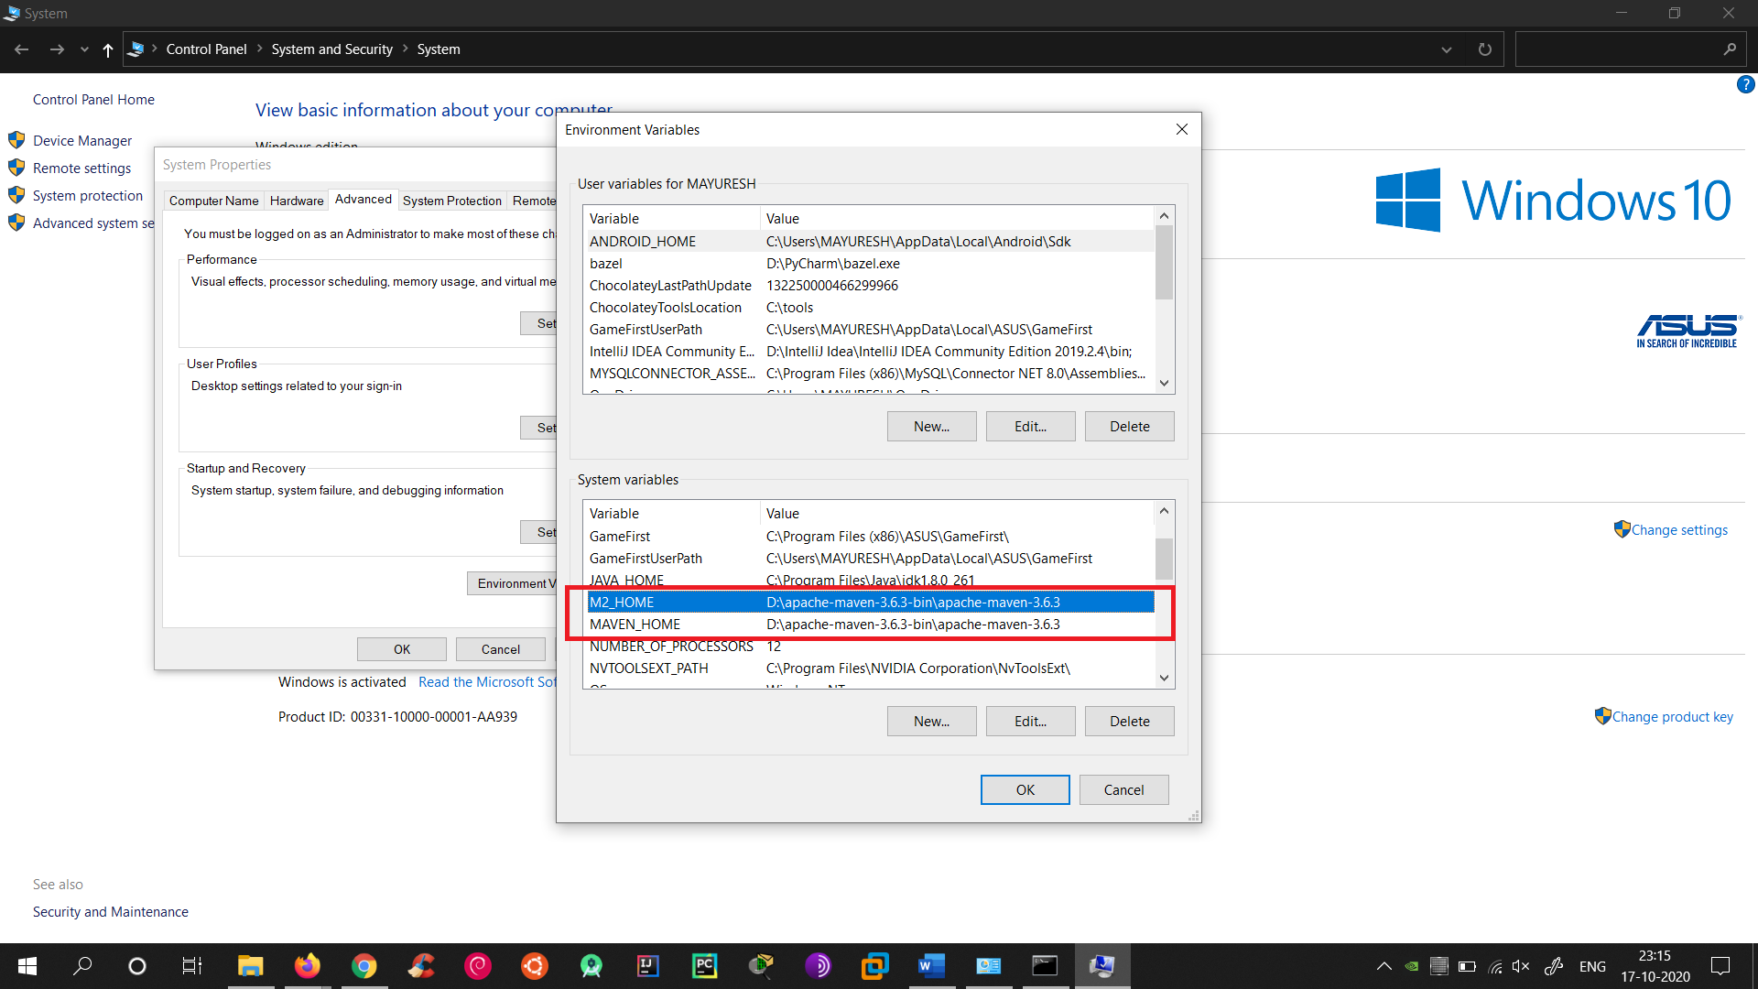

Open **CMD** and type **mvn**

If everything is OK, then your will see following output.

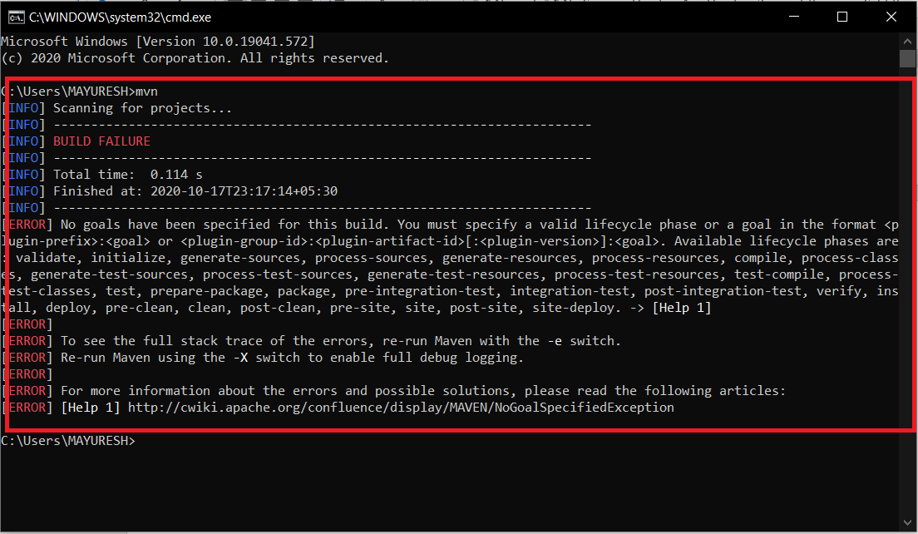

**Step 7: (Optional) Install Tomcat Server**

Open

<https://tomcat.apache.org/download-80.cgi>

Select the **Installer option** from **Downloads**.

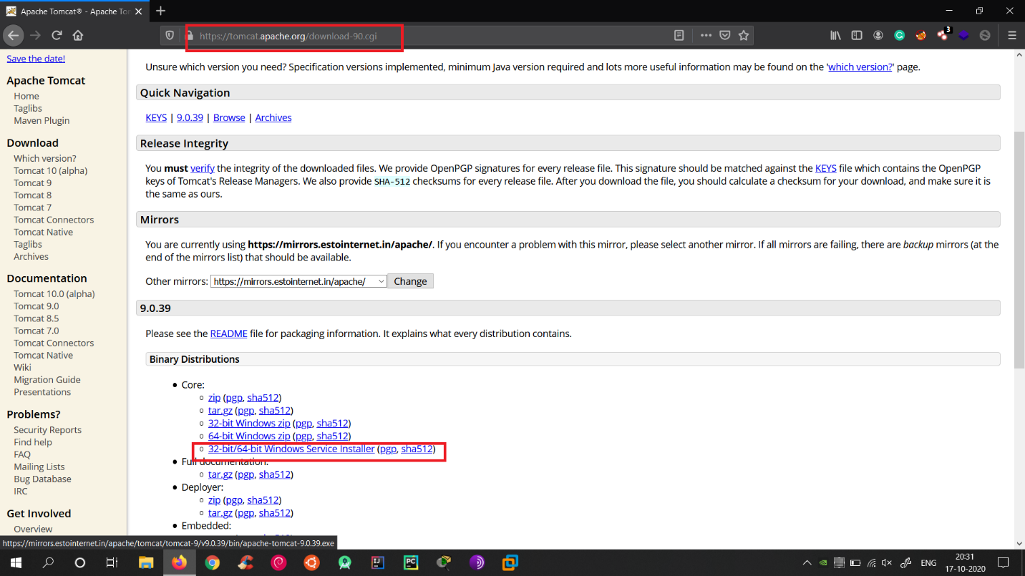

After downloading just click on Next and Install it.

**Step 8: Open Project in IntelliJ Idea**

Open IDE.  
Click on **Open or Import**

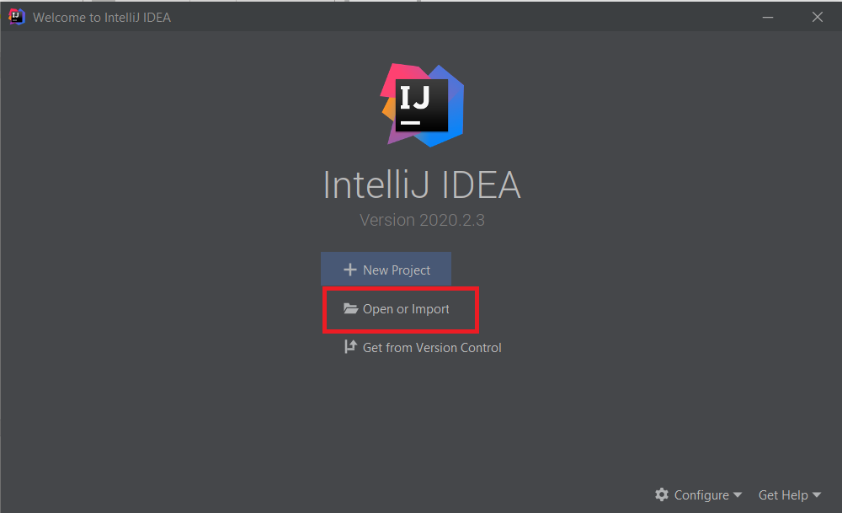

Now **select the Folder** which contains the **pom.xml file.**  
**(Note: Select the Folder)**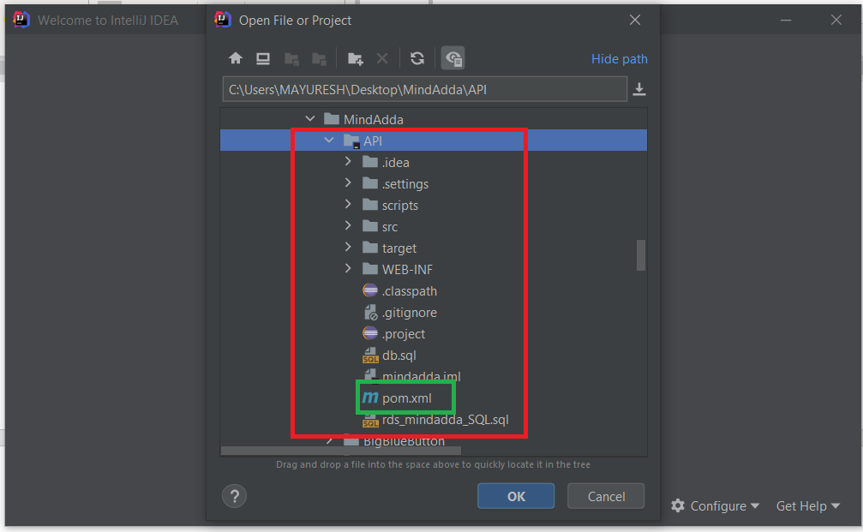

Click **OK**.

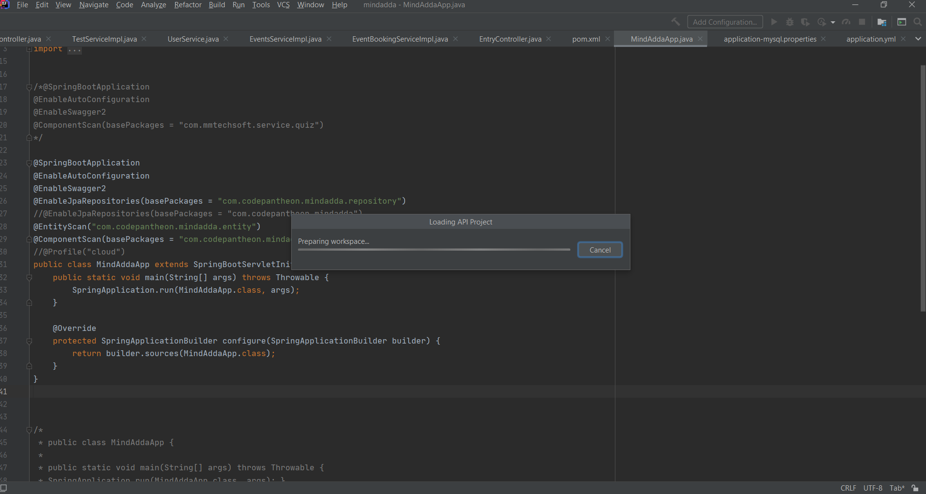

The project will now be imported by downloading required packages.

**Step 9: Run the Program**

Open this file and check values.

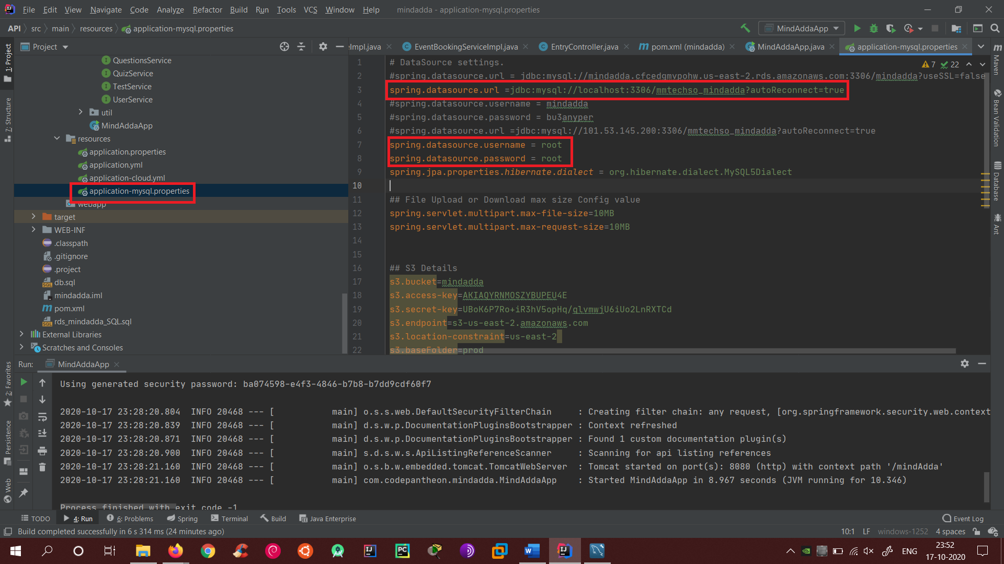

Now open **MYSQL Workbench** and click on the **Connection** we created previously.

A new window will be opened.  
Now click on **Data Import/Restore**.

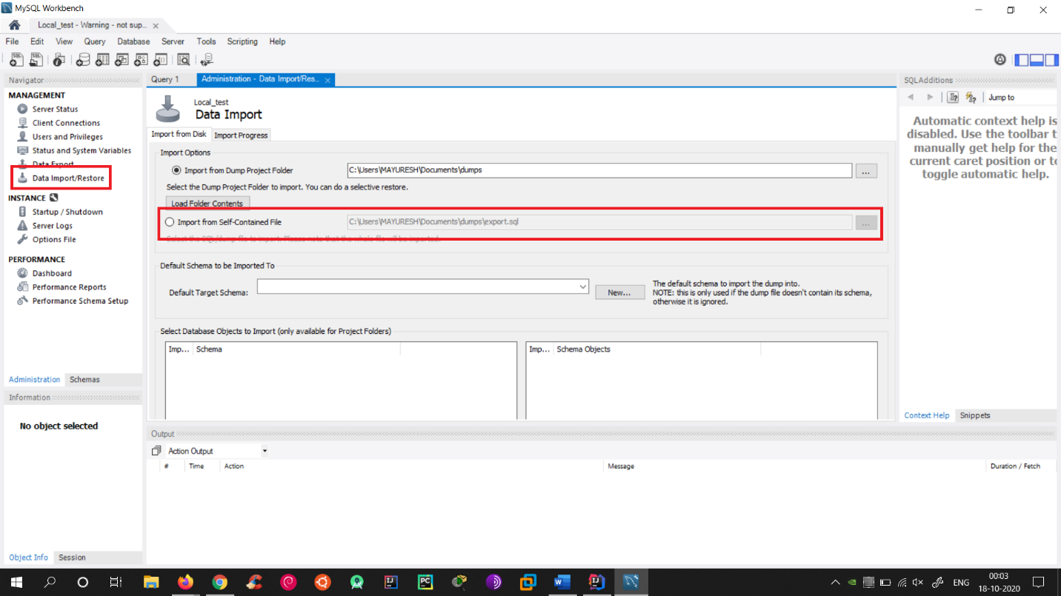

Select the option **from file** and select **the latest .db file**.

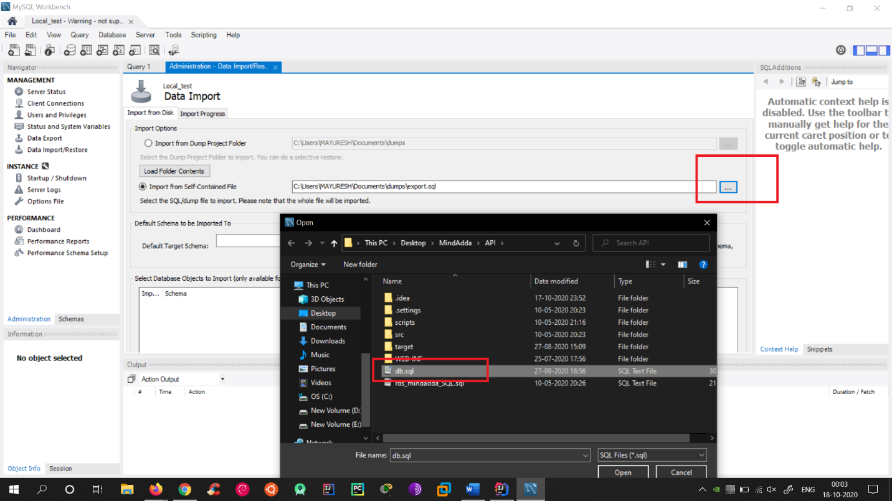

In the Schema select **New** and name the Schema as **mmtechso_mindadda** and click OK.

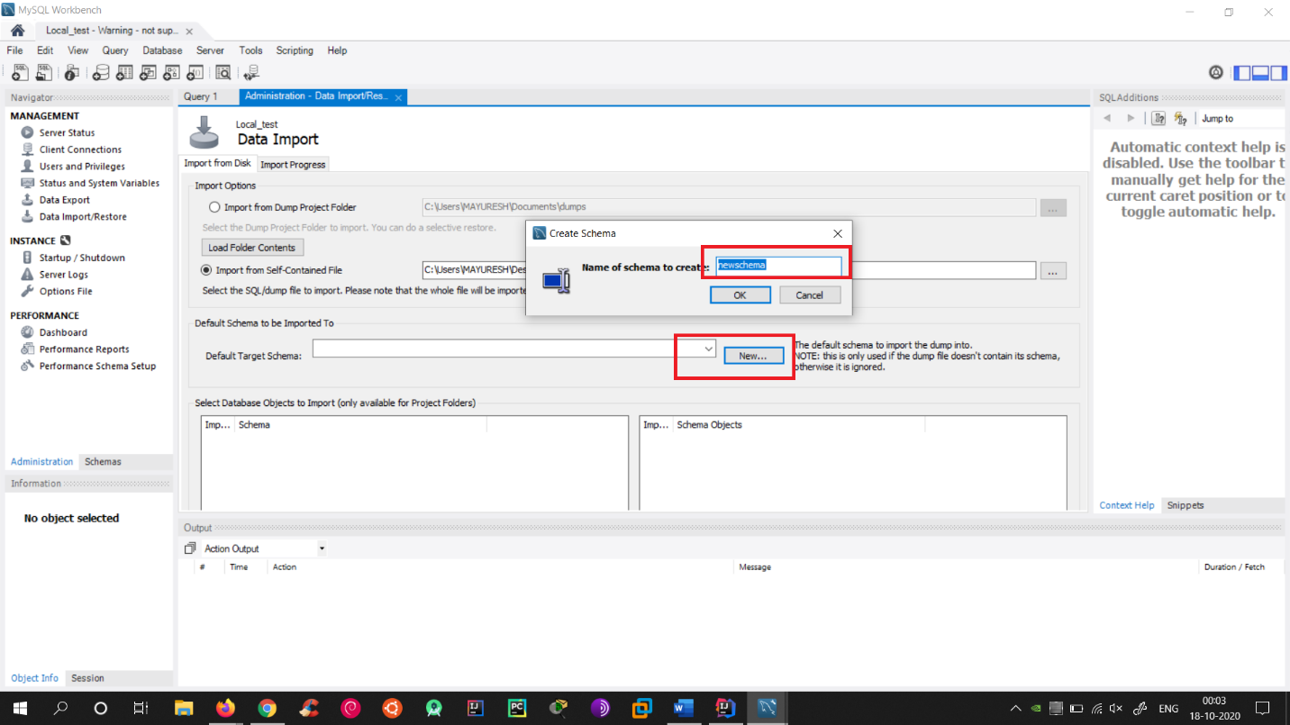

Now click on **Import Progress** and click **Start Import**.

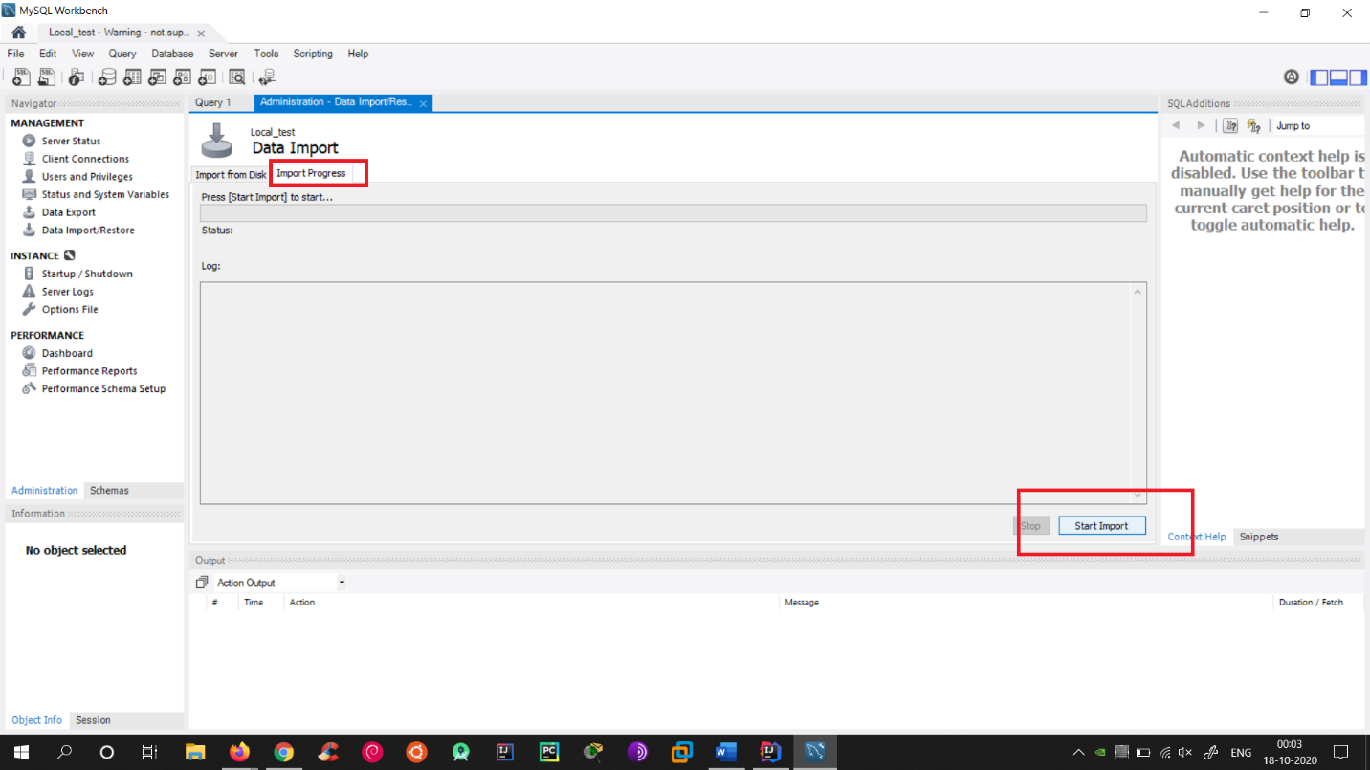

If everything is **correct**, then you will see output as this.

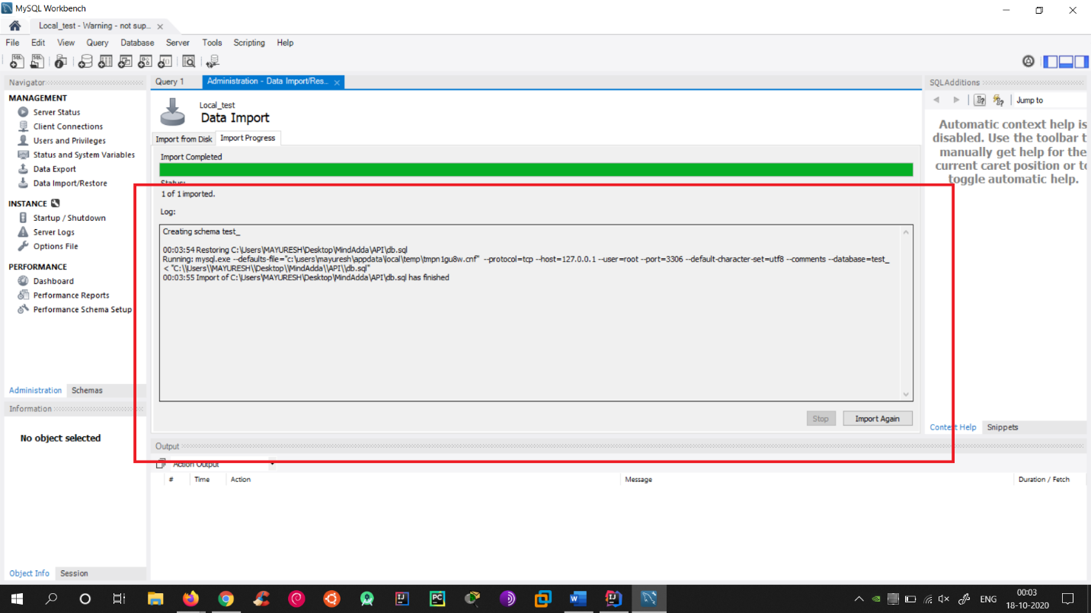

Now open IntelliJ Idea and Press the Play Button on top-right bar.

If you see output as this then your Backend Server is configured properly and running.

